Reading Interest Survey
Name______________________________________________ Grade______
I prefer to read (circle one):
Fiction
Non-fiction
I like them both
I prefer to read (circle one):
Books in a series
Books that are not part of a series
I prefer them both
The last book I read, and enjoyed, was:____________________________________________________
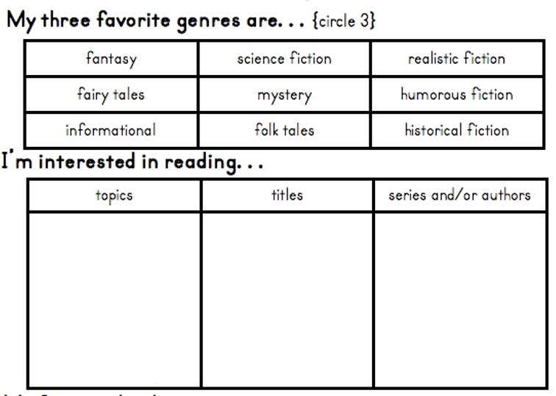
How do you feel about reading?___________________________________________________________
_____________________________________________________________________________________

